## WatchIO in the sensorlist

Since revision 3904 the new setup of implementing WatchIO is in effect. WatchIO is the main protocol of the Unimacs bridges.

We will focus on the columns that are important. The other columns will all practically work the same as described earlier.

First make sure that the devices are set in the Devicelist. NavVision has to know where to look for the device. The following figure shows the mandatory fields for the devicelist:

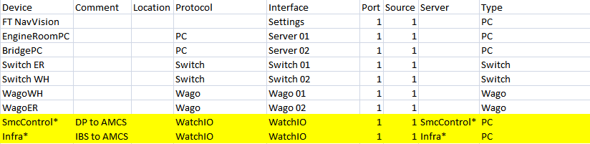

Figure 14‑7: Devicelist WatchIO

|  |  |
| --- | --- |
| Field | Description |
| Device | The name of the WatchIO view the asterix (*) at the end is needed for redundancy |
| Comment | Free text |
| Location | Free location name |
| Protocol | Protocol must be WatchIO |
| Interface | Interface must be WatchIO |
| Port | Every protocol has to have a unique port number |
| Source | Mostly one |
| Server | Same as Device |
| Type | Type must be PC |

Table 14‑1: Devicelist WatchIO

In the sensorlist we also have a slightly different approach. While the main fields will be the same we will focus on the differences by the following example”

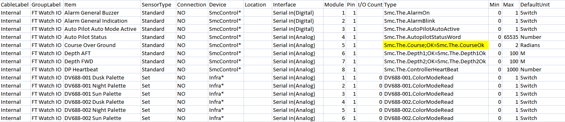

Figure 14‑8: Sensorlist WatchIO

|  |  |
| --- | --- |
| Field | Description |
| Cable label | Free (preferably “Internal”) |
| Group Label | Free |
| Sensortype | Preferably “Standard” only when you want to set something or you just need a part of the variable. For the last one use “Enum” |
| Connection | NO |
| Device | Choose the one from the devicelist |
| Location | Free |
| Interface | Serial in Analog or Digital |
| Module | A unique number. Start with 1,2,3…..etc. |
| Pin | 1 |
| I/O count | Free |
| Type | Here you need to put the type Variable. You can get that from the Unimacs program. For status you also put the OK-Variable behind a semi-colon. |
| Min | Normal Min settings |
| Max | Normal Max settings |
| DefaultUnit | Normal DefaultUnit |

Table 14‑2: Sensorlist WatchIO

The rest of the fields is to be treated the same as mentioned earlier in this document.

*: for further configuration refer to the “ACC-Software-Installation-and-Commissioning-Manual”*